**Viewport is the browser window size. 1vw = 1% of viewport width. If the viewport is 50cm wide, 1vw is 0.5cm.</p>**

**XML PARSER**

As a reminder, “parsing” refers to the process of analyzing data. This includes reviewing strings and text to ensure that it follows the syntax of a given language.

A parser is the part of a program that performs parsing. It verifies that the required information is present and that syntax is adhered to.

An XML parser reads XML and makes it possible for the XML to be used by programs and websites. Browsers have XML parsers built into them.

Before accessing an XML document, the document has to be loaded into an object within the XML DOM. XML has its own DOM that defines the properties (characteristics) and methods (actions) related to accessing and editing XML.

Prior to showing you some XML code, there are some terms to define:

* The “new” operator is used to create an object
* The “parseFromString” method creates an XML object from a string
* “DOMParser” is used to create a DOM object from an XML string
* As a reminder, the “childNodes” property returns a specified child node by index number.
* The getElementsByTagName() method returns a collection of elements using a tag name

Here is how the code would look within an HTML file:

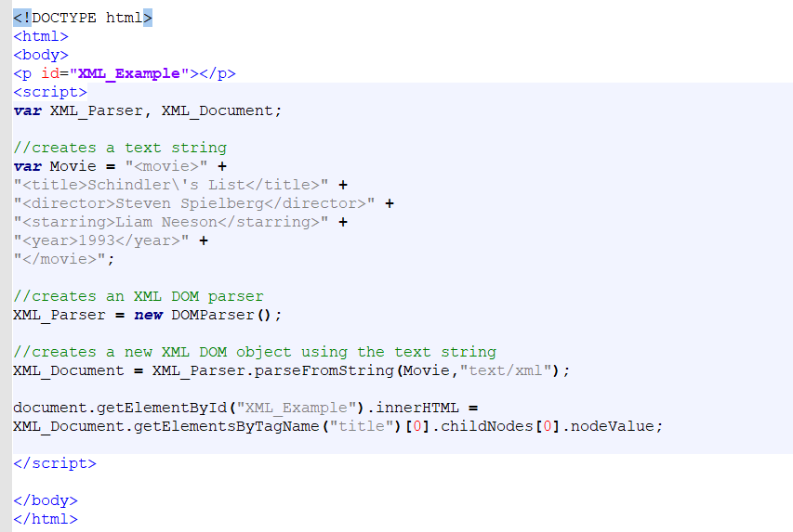

We created our own XML tags

**NODES AND THE DOM**

In the DOM, every item within an HTML document is a node.

This means: every element is a node (an element node), text inside elements are nodes (text nodes) and comments are nodes (comment nodes). Even the document itself is considered a node (document node).

These nodes have object-oriented relationships (i.e. parent and child).

In this DOM tree:

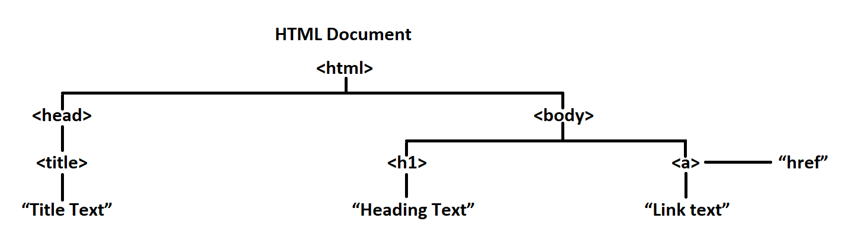

In this tree, the <html> element is the parent node.

The <head> and <body> elements are the first child nodes of the <html> node and the <title>, <h1> and <a> elements are the last child nodes.

Additionally, the following is true as well:

* The <title> element is the child node of the <head> node
* The “Title Text” is a text node, and the child of the <title> node
* The <body> element has two child nodes: <h1> and <a>

And so on.

The childNodes[indexnumber] property can be used to navigate child nodes. For example: childNodes[0] could be used to access the <h1> element when used in relation to the <body> element